From: <https://strategic-culture.org/news/2023/04/30/what-china-really-playing-in-ukraine/>

Now also found at: <https://www.zerohedge.com/geopolitical/escobar-what-china-really-playing-ukraine>

Written by: Pepe Escobar

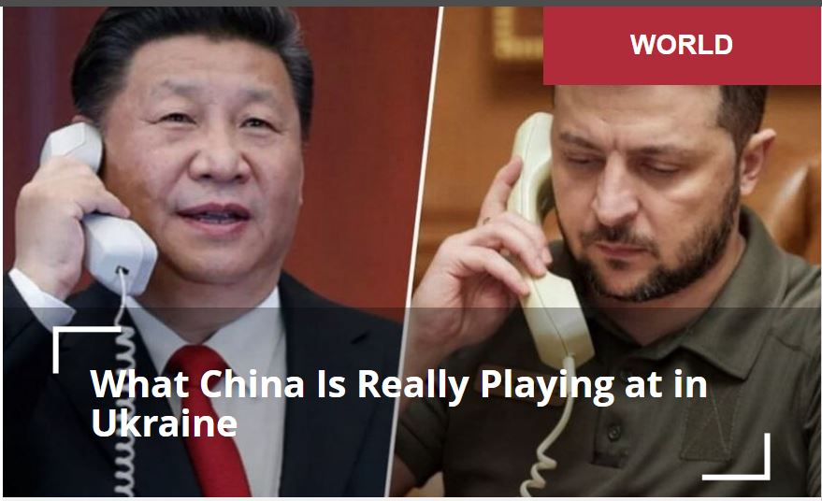

***Beijing is fully aware the NATO proxy war against Russia in Ukraine is the un-dissociable double of the U.S. war against its Belt and Road Initiative.***

Imagine President Xi Jinping mustering undiluted Taoist patience to suffer through a phone call with that warmongering actor in a sweaty T-shirt in Kiev while attempting to teach him a few facts of life – complete with the promise of sending a high-level Chinese delegation to Ukraine to discuss “peace”.

There’s way more than meets the discerning eye obscured by this spun-to-death diplomatic “victory” – at least from the point of view of NATOstan.

The question is inevitable: what’s the point of this phone call? Very simple: just business.

The Beijing leadership is fully aware **the NATO proxy war against Russia in Ukraine is the un-dissociable double of an American direct war against the Belt and Road Initiative (BRI).**

Until recently, and since 2019, Beijing was the top trade partner for Kiev (14.4% of imports, 15.3% of exports). China essentially exported machinery, equipment, cars and chemical products, importing food products, metals and also some machinery.

**Very few in the West know that Ukraine joined BRI way back in 2014, and a BRI trade and investment center was operating in Kiev since 2018.** BRI projects include a 2017 drive to build the fourth line of the Kiev metro system as well as 4G installed by Huawei. Everything is stalled since 2022.

Noble Agri, a subsidiary of COFCO (China National Cereals, Oils and Foodstuffs Corporation), invested in a sunflower seed processing complex in Mariupol and the recently built Mykolaiv grain port terminal. The next step will necessarily feature cooperation between Donbass authorities and the Chinese when it comes to rebuilding their assets that may have been damaged during the war.

Beijing also tried to become heavily involved in the Ukraine defense sector and even buy Motor Sich; that was blocked by Kiev.

**Watch that neon**

So what we have in Ukraine, from the Chinese point of view, is a trade/investment cocktail of BRI, railways, military supplies, 4G and construction jobs. **And then, the key vector: neon.**

Roughly half of neon used in the production of semiconductors was supplied, until recently, by two Ukrainian companies; Ingas in Mariupol, and Cryoin, in Odessa. There’s no business going on since the start of the Special Military Operation (SMO). That directly affects the Chinese production of semiconductors. Bets can be made that the Hegemon is not exactly losing sleep over this predicament.

Ukraine does represent value for China as a BRI crossroads. The war is interrupting not only business but, in the bigger picture, one of the trade and connectivity corridors linking Western China to Eastern Europe. **BRI** conditions all key decisions in Beijing – as it **is the overarching concept of Chinese foreign policy way into mid-century.**

And that explains Xi’s phone call, debunking any NATOstan nonsense on China finally paying attention to the warmongering actor.

As relevant as BRI is the overarching bilateral relationship dictating Beijing’s geopolitics: the Russia-China comprehensive strategic partnership.

**So let’s transition to the meeting of Defense Ministers of the Shanghai Cooperation Organization (SCO) earlier this week in Delhi.**

The key meeting in India was between Russian Defense Minister Sergei Shoigu and his Chinese colleague Li Shangfu. Li was recently in Moscow, and was received by Putin in person for a special conversation. This time he invited Shoigu to visit Beijing, and that was promptly accepted.

Needless to add that every single player in the SCO and beyond, including nations that are for the moment just observers or dialogue partners as well as others itching to become full members, such as Saudi Arabia, paid very close attention to the Shoigu-Shangfu camaraderie.

When it comes to the profoundly strategic Central Asian “stans”, that represents the six feet under treatment for the Hegemon wishful thinking of using them in a Divide and Rule scheme pitting Russia against China.

Shoigu-Shangfu also sent a subtle message to SCO members India and Pakistan – stop bickering and in the case of Delhi, hedging your bets – and to full member (in 2023) Iran and near future member Saudi Arabia: here’s where’s it at, this is the table that matters.

All of the above also points to the increasing interconnection between BRI and SCO, **both under Russia-China leadership**.

BRICS is essentially an economic club – complete with its own bank, the NDB – and focused on trade. It’s mostly about soft power. The SCO is focused on security. It’s about hard power. Together, **these are the two key organizations that will be paving the multilateral way.**

**As for what will be left of Ukraine, it is already being bought** by Western mega-players such as BlackRock, Cargill and Monsanto. Yet Beijing certainly does not count on being left high and dry. Stranger things have happened than a future rump Ukraine positioned as a functioning trade and connectivity BRI partner.

*The views of individual contributors do not necessarily represent those of the Strategic Culture Foundation.*